In many fields, IoRT has been widely used and the machine learning is undoubtedly one of the key links. Here is a good example which shows how robots can help people have a better response to some major disasters.

There are a lot of major disasters on the earth every year, like earthquakes, tsunamis, typhoons, etc. When these disasters happen, the time will be very precious. For people, the most significant thing is how to save as many people as possible in such a short period. Robots can offer a lot of help to people once they receive deep learning. One paper [1] has presented a good solution on how to incorporate these robots and IoT to establish an IoRT architecture. From Fig.1, the first step is to use mobile robots to collect data from Workstation or the local environment. And then the remote network will use these data to build an AI model. After that, the system will evaluate the AI model. Then the Cloud will deploy the trained AI model to the local workstation for further testing the performance. The model ultimately will be deployed into the embedded system in robots for the next loop of learning process.

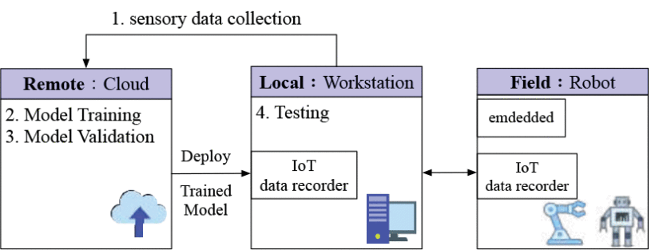

Fig1. Architecture of IoRT in disaster response

The solution can make the robots have enough “experiences” about how to respond to disasters in one area through several learning processes. However, different places have different environments. If one robot only has memory on the environment of one place, it cannot be appointed to other places to carry out rescue missions. One idea is that the cloud can store different AI models for various environments. Once there is a disaster happening in one place, the AI model of that environment should be directly deployed to robots so that these robots can attend the rescue mission immediately in that area.

This kind of robot can help people in many aspects. In an earthquake, robots can detect the victim’s position with sensors and help people remove reinforced concrete that collapsed. If someone is trapped under the ruins and cannot get out temporarily, the robots can be responsible for transporting food and drink to help the victim maintain the nutrition they need. With the help of robots, the success rate of rescue operations and the survival rate of victims will be greatly improved.

Another example is in precision agriculture. With the help of mobile robots, more information about agriculture can be collected to increase crop yield and decrease the environmental hazards. Once data is transmitted to the cloud, it can be processed and stored in the web applications. One paper [2] design a good system integration between mobile robots and the server. From Fig.2, data which contains temperature, humidity, pressure, light measurement and other kind of information can be obtained by environment sensors, power board or other measurements. These data will be sent to Jetson Tx1 to be assembled in JSON format. And then Jetson Tx1 will create channel with server and send JSON packet to server. The server will process the packets and store data. Once finishing the communication, the Jetson board will close the channel.

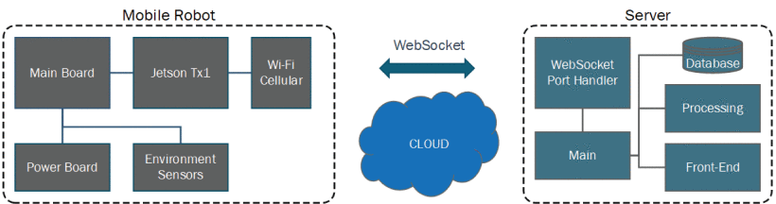

Fig2. IoRT in agriculture

The solution is not very complicated so the period of deep learning is not too long. If the web applications in the server can give information easily and clearly, and if mobile robots can collect comprehensive and correct data, this system will become robust, reliable and usable. And it will become a prospective commercial product.

These data which collected by robots can help people develop appropriate agricultural plans for climate change. The server will process these big data to save a lot of time for human. Combined with large-scale mechanized agricultural production technology, it will be possible to realize automatic agricultural management in the future.

The application of a massage robot [3] can be a representation of IoRT in medical field. The massage robot operating in IoT can help collect data for future analysis. In the current technology background, IoT medical devices represent a future development direction.

The use of IoRT can also be seen in people’s daily life. One paper [4] proposes a good solution about waiter robots in restaurants. From Fig.3, the information about table number and menu will be stored in QR code. When the customer scan QR code and decide what he wants to have, the order (which contains table number and ordered items) will be sent to the chef and the manager. And then the chef will make the item and call the robot to transmit the item. Once the robot delivers the order, it will also send information to the manager. The whole system is automatic and QR code is stored in the network.

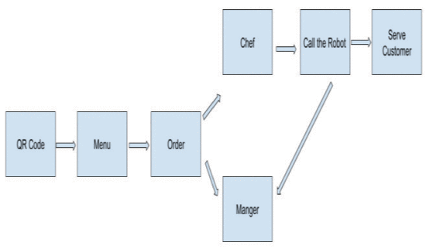

Fig.3 restaurant automatic system

The solution is simple and the (basic) machine learning does not need to occupy much time. But it lacks some emergency measure. The waiter robot may encounter some problems such that the walking route is blocked. And the waiter robot cannot speak with customers, which may leave customers a bad impression. So there are much future work needed to be done to improve these kind of robot.

If this kind of robot is widely used by restaurants, it will save a lot of money for the employers. They do not need to employ waiters and the robots can provide faster service.

In short, many people have studied the application of IoRT in the academic field, and some research results have been put into commercial use. It can be imagined that under the background of 5g commercial implementation, IoRT technology will be more developed.

1. M. -F. R. Lee and T. -W. Chien, "Artificial Intelligence and Internet of Things for Robotic Disaster Response," 2020 International Conference on Advanced Robotics and Intelligent Systems (ARIS), Taipei, Taiwan, 2020, pp. 1-6, doi: 10.1109/ARIS50834.2020.9205794.
2. M. -F. R. Lee and T. -W. Chien, "Artificial Intelligence and Internet of Things for Robotic Disaster Response," 2020 International Conference on Advanced Robotics and Intelligent Systems (ARIS), Taipei, Taiwan, 2020, pp. 1-6, doi: 10.1109/ARIS50834.2020.9205794.
3. W. Si, G. Srivastava, Y. Zhang and L. Jiang, "Green Internet of Things Application of a Medical Massage Robot With System Interruption," in IEEE Access, vol. 7, pp. 127066-127077, 2019, doi: 10.1109/ACCESS.2019.2939502.
4. T. M. N. U. Akhund, M. A. B. Siddik, M. R. Hossain, M. M. Rahman, N. T. Newaz and M. Saifuzzaman, "IoT Waiter Bot: A Low Cost IoT based Multi Functioned Robot for Restaurants," 2020 8th International Conference on Reliability, Infocom Technologies and Optimization (Trends and Future Directions) (ICRITO), Noida, India, 2020, pp. 1174-1178, doi: 10.1109/ICRITO48877.2020.9197920.